

**Royal British International School**www.royalbritishinternational.com

**Name: ____________________________ Date:_______ Mark: _____**

**COUNTING MONEY**

1.) ________________





2.) _______________





******3.) ______________



4.) ___________







5.) ____________

************





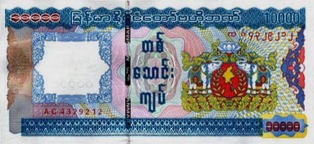6.) _____________

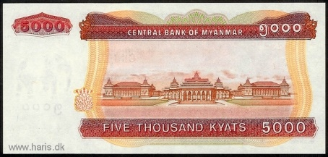

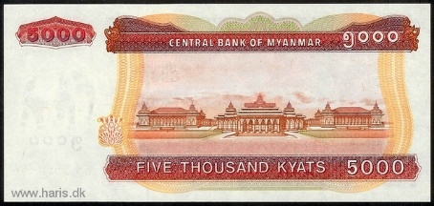

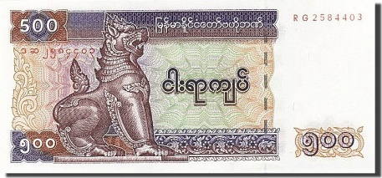7.) ____________

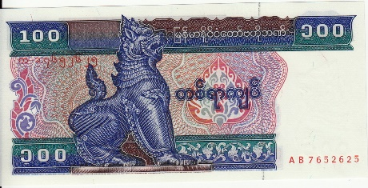

8.) _____________

